Guidelines for the interface

The prototype has a standardised task sequence in the sense that whichever user type is logged in, the same structure is applied. There is a landing page for the lecturer, student, and admin, with a similar side bar which can take the user to their relevant pages. The lecturer and student view share the same intuitive structure and what is labelled when clicking a link to another page is what the user gets every time. When users click on a row in a table, they are always sent to the page corresponding to that information and in the student exam view, for example, the questions are displayed in a uniform way, one question per page, therefore the student knows how the exam will be structured once experiencing the first two pages.

The prototype also ensures that the embedded links are descriptive, in the sense that when clicking on a link to manoeuvre from one page to another, there is always a label so that the user knows where the link is taking them. The best example is the sidebar, which all types of users have in their pages, and can conveniently link them to the most basic of pages that their account type requires. Another example is The Go Back, Save and Submit buttons when the lecturer is correcting an exam, as these say exactly what they do, provide a unique and important function, and are labelled and place intuitively.



Figure - The Go Back, Save and Submit buttons.

The prototype also makes use of unique and descriptive headings. In the student and lecturer overviews (landing page), for example, the three most important sections that these users can access are the actives exam, upcoming exam, and past exams. These use a unique font size heading so as to separate them from other information and make sure that they stand out. There title is directly related to the information they represent. The same can be said for the titles of the exams and the question titles.

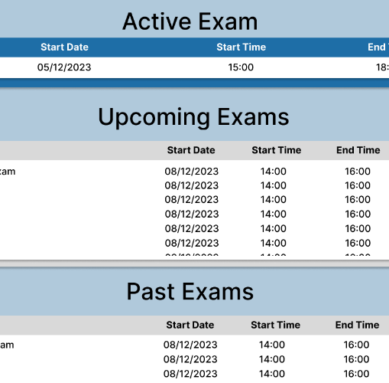

Figure - The Exam Type headings

The prototype makes use of the appropriate button types according to what type of question it is. This means that when the options are mutually exclusive, radio buttons are used, and when they are mutually inclusive, checkboxes are used.

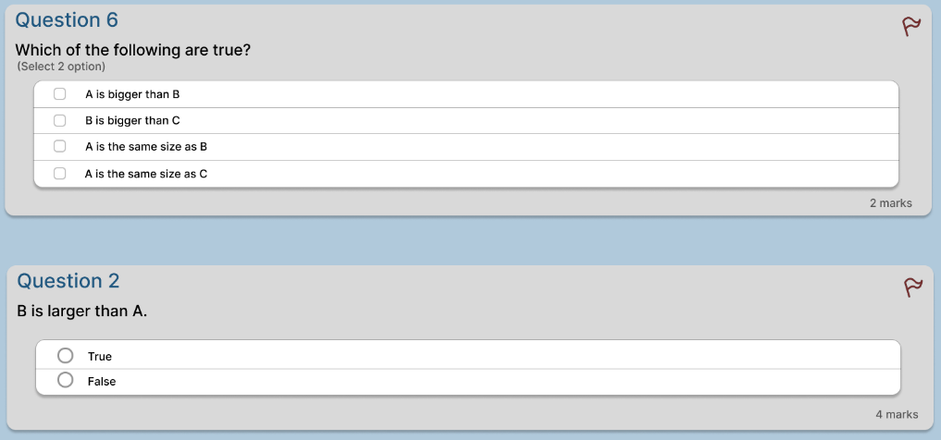

Figure - Button Comparison

It was also ensured that the prototype passes guidelines to promote accessibility such as use of contrast checkers: <https://webaim.org/resources/contrastchecker/>.

The colour palette used was blue and white and this remained consistent throughout the prototype. It was made sure that there is separation of foreground and background through background boxes behind certain parts of the prototype, to ensure clarity. This was done constantly through every page. It was also made sure that the same structure and functionality is consistent throughout the different pages to make the functionality predictable for the user and ensure better user experience. An example of this would be how students always have the questions displayed in the same place and in the same manner, and it was also ensured that the way that information is displayed is easy to visually digest at a glance. There was no overload of information and there was separation of different type of information on the screen. For example, the types of exams in the student and lecturer overview are separated in such a way that shows visual clarity.

There is also a consistency of data display throughout the prototype. Examples of this is the colour scheme, which is uniform throughout the whole prototype. The terminology used is also consistent throughout, and the placement of certain information is very dependable. For example, in the student view, the name of the exam and the respective lecture, alongside the ability to view the rubric and the question boxes, is always at the top, and the different questions are displayed at the bottom. They always have the same size boxes and displayed in the same location. The way that data is presented is very intuitive and once the student sees more than one question, they already know how the rest of their experience in the prototype will be, as everything is constant.

The same can be said for the lecturer, as the student and lecturer views are similar in terms of the structure of the display. The admin view is also streamlined in this way. It makes use of different content but the way in which different pages are displayed is consistent and intuitive.

The whole prototype also makes use of the same type of font, font colour and styling. There is little changes in the styling of text, it makes use of heading with larger font only in parts that the information is more important and where headers are needed, such as Upcoming Exams, Current Exams and Past Exams, this is done so that when text is emphasised it is justified, and it actually catches the user attention.

The prototype ensures that the user will be able to efficiently assimilate information. This is done by having the prototype similar in format to other productivity software, especially ones related to exam. This means that the prototype makes use of ubiquitous components such as sidebars and headers, and the way that information is displayed makes use of web standards that any user who has made use of this type of software in the past will find familiar. Examples such as the closing X in the top right, making use of google icons with their respective meaning (look at fig.1), having different types of information separated in their respective parts and making use of HTML staples such as forms.

The rows and columns are organised neatly, and when the user hovers over a row it is highlighted so that it is neater and provide more clarity. Most of the text is left justified except for when it is more sensible to centre justify them for emphasis, such as the welcome page.

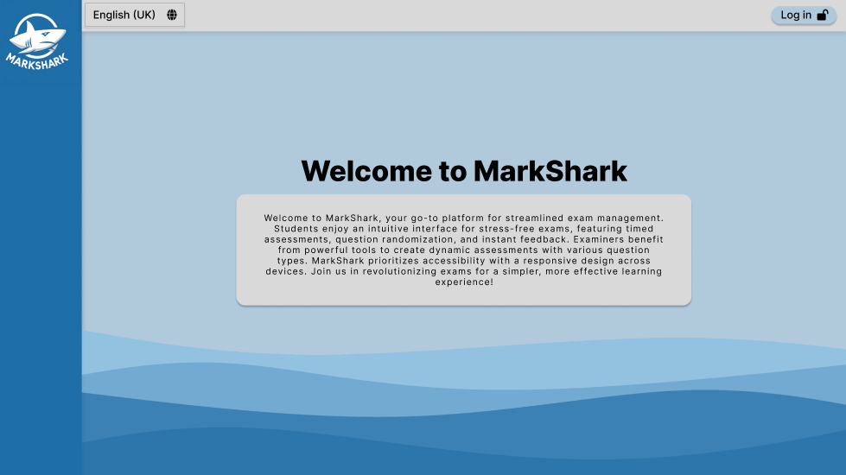

Figure - Welcome page having centre justified text and heading for emphasis.

It was also ensured by the team that the user had minimal memory load. This means that each screen displayed all the necessary information and that there was no need for the user to remember what was displayed in a previous or other screen. One of the many examples of this is when the lecturer clicks on one of the previous exams so that they see a list of submissions to correct them. When taken to the correction list page, the title of the exam, percentage of the correct exams, as well as the submission deadline are displayed in the header so that the information displayed form the page you came from is repeated. This is convenient because this information is important for this page as well, so there is a carry-over of information.

The prototype is built in such a way that any action only takes a few clicks to complete. For example, for the student to go into an exam, it is only 3 clicks from the welcome page, and for the lecturer to correct a specific submission of a student, it is only 4. This is because the prototype is split in such a way that maximizes screen space, making use of different parts of the screen to display important information, and there is no need for multiple pages to be opened to go to a specific functionality.

There are also multiple examples where the output field is also used as input field where possible. This means that the input field has greyed out text when it is not selected, outlining what needs to be inputted. This makes the display neater and maximize screen space. An example of this is in the exam creation page. It was also made sure that when the button does have an input, the border is lighter and the same shade of the text, whilst those that do not have an input have darker borders, for clarity.

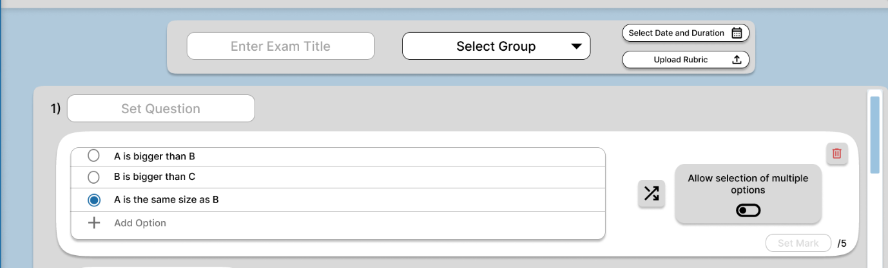

Figure - Output/Input field examples

The prototype ensures that it is consistent in formatting of all displays. So, headers, sidebars and menus are all consistent in terms of size, shape, location, font, etc… The data displayed on screen is only one that is relevant to the task at hand, i.e., what the reason the user clicked a link to that page.

Since the functionality of an admin is very important to the overall functionality of the system, it is very important that the admin is informed when a new feature is implemented, so that the functionality and productivity of the system can be maximised, and that the effort and development time is amplified. This is why in the admin overview there is a use of darker background in the ‘New Feature’ section, so that there is an emphasis and a guarantee that the user will acknowledge this. The font is large, the background colour is darker, the box is placed at the top of the screen and the font is bold.

This technique is also used in the ‘Active Exam’ section in both the lecturer and student overview. This is because such a time-critical and important section of content is a must-see for the user. It displays the exam that is about to start or has started, and when the user, especially the student, logs in, it is the first thing that meets the eye. It makes use of a darker colour again for the background colour, it is the first thing at the top of the screen and has a larger box background than the others, to ensure emphasises and acknowledgement.It was made sure that this techniques was used sparingly and not overused so that the critical information that we wanted the user to really acknowledge is given emphasis and distinction from other information.

When it comes to data entry, there was an effort so that forms are all consistent, and easy to read. Both the ‘Create Account’ and ‘Edit Account’ modals in the admin view have very similar structure and make use of the same type of information and the same order as one would expect form a basic form. The same goes for when the student is prompted to type a short answer or essay when taking an exam. The box makes use of ubiquitous standards; a scrollable data entry box that can have font settings customised.

The creation of exams in the lecturer view also has commonly used data entry systems. It has an output/input field for clarity, makes use of a Gray ‘+’ sign icon for adding new information, and red bin icon for deletion. The lecturer is allowed to shuffle the option order when the student is presented with the questions and makes use of the easily distinguishable shuffle icon, and also has a toggle button to switch the button type. These are all staples in quiz/exam creation.

It was also ensured that there are minimum input actions by the user when making use of data entry. When possible, the user is prompted for a selection of a list of choices instead of data entry, such as the drop-down selection for the ‘Groups’ in the lecturer exam creation, and as already mentioned there is a constant insurance of minimal memory load on the user, i.e., all the required information of a page is displayed in it and the user does not need to remember details from a previous page. The format of data entry is also similar to the formatting of other displayed information for consistency and clarity. For example, the exam creation page is very similar to the exam correction page, so when the lecturer goes to correct an exam, they are already familiar with the structure from when they created it.

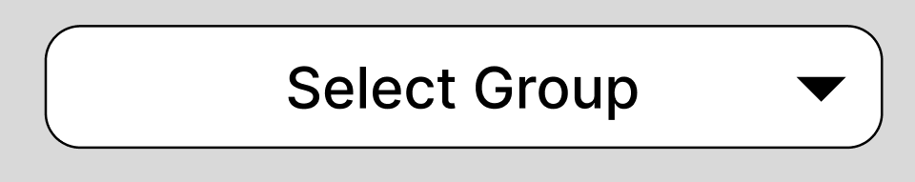

Figure - Examples of drop-down selection

These is also flexibility for the user to control data entry, in the sense that since different users have different ways in which they like to input data for maximum productivity, so it was ensured that there are different ways of doing so. Customisation options such as allowing different font types and colours for the student when writing a short/long answer, as well as lots of different customisation options for the lecturer when creating an exam, such as the shuffling of the order, the ability to move order of options and questions in exam creation, and the freedom of deletion, change of mark value and change of button type/multiple options.

Some other examples of guidelines for the interface in this prototype include clarity and simplicity. There was an effort for clear and concise language use, and minimal clutter and complexity. Everything is split so that different parts of relevant information are together according to their function. There was an emphasise on clarity. There was no use of really bright or really dark colours, it was made sure that the text background provided contrast for readability and the use of ubiquitous icons was used.

There was also use of feedback and notification to the user. For example, before submitting an exam, or before the lecturer published an exam or completed a correction, there is a confirmation modal that allows them to either go through with it or go back. This allows for better user engagement and feedback. There was also a clear separation of user profiles and their permissions. With each log in, different permissions are assigned (student, lecturer, and admin). The admin has administrative purposes that allows managing of the other accounts, whilst the student is able to take exams and view results and the lecturer create the exams and correct results.

Therefore, the prototype values and follows many principles and guidelines of user interface design. It takes into account many factors to ensure the user experience and the user design are up to par and that the user has, as much as possible, a seamless and smooth experience.